OBJECTIVES:

* DATABASE TERMINOLOGY
* SQL LAB

**THERE ARE SIX PRINT SCREENS/Q & A, EACH WORTH 16.6%**

A **database** is a storage structure that allows data to be entered, manipulated, and retrieved in various formats.

A **database management system (DBMS)** is used to create and maintain the structure of a database, and then to enter, manipulate, and retrieve the data it stores.

Creating an efficient database is a process called **Normalization**. A normalized database does not contain redundancy or duplications and data anomalies (data inconsistencies).

A **field** is also called a **column** and a **record** called a **row**. A **table** contains fields and columns that make up the data.

**The entity Relationship (ER) Model** is a diagram of relationships among multiple tables. It helps us to better understand the design of the database. An Entity Relationship Model is a diagram that identifies entities such as customers, books, orders, and such).

An **entity** is any person, place, or thing.

**One-to-One Relationship** is when each occurrence in one entity is represented by only one occurrence of data in the other entity. For example: if each classroom is assigned to only one academic division, this creates a one-to-one relationship between the classroom and division entities.

Divisions

Classrooms

**One-to-Many Relationship** is when each occurrence of data in one entity can be represented by many occurrences of the data in the other entity. For example, a class has only one instructor, but the instructor may teach many classes.

Classrooms

Instructors

**Many-to-Many Relationship** is when data can have multiple occurrences in both entities. For example, a class can consist of more than one student, and a student can take more than one class.

Students

Classes

A **primary key** uniquely identifies a column so no duplications can be entered.

A **foreign key** is to establish a relationship with another table or tables.

A **sequence** is a sequential list of numbers the database automatically generates and that guarantees each primary key value is UNIQUE.

**Normalization** is the process of reducing REDUNDANCY and DATA ANOMALY. Redundancies are repeating data and Data anomalies are inconsistent data.

**Starting of Module 1 Class Exercise #1**

1. To begin Oracle, open the Go to Database Home Page under the Oracle Database 10g Express Edition folder. This will use your web browser to navigate to the login information.

**Note**: if you get an error, under the type here to search type **services >> right-click on the OracleServiceXE and click on the restart.**

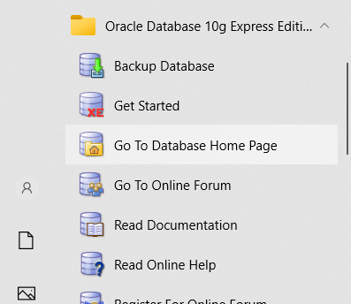

1. Type the system as the username and the password you chose during installation.

Designing a table

1. Here is an example in creating an employee’s table with a primary key on the EMPID column.

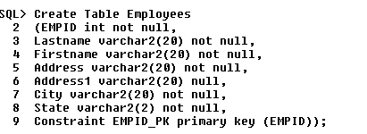

**#1 PRINT SCREEN YOUR SCRIPT BELOW HERE**

Displaying the structure of the table



Selecting from the table



The asterisk (*) means to select all columns and rows from a table. It’s also called a WILDCARD.

Inserting data into the table



Notice here we are placing single quotes around columns that contain Varchar2 which is used for data and numbers. The Int data type does not need single quotes.

Selecting from the table



**#2 AFTER RUNNING THE (SELECT * FROM EMPLOYEES) PRINT SCREEN YOUR SCRIPT AND RESULTS ARE BELOW HERE**

Specifying during the insertion of data

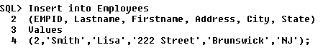

Notice here we are specifying which columns we want to insert. Remember, you can only skip columns that has a NULL constraint.

Adding a new column to an existing table



Selecting from the table



Updating a table



Selecting from the table



**#3 CHALLENGE EXERCISE**

Update (EMPID 2) zip code to 22222

Why should you NOT use the Last name, first name, Address, City, or State columns when updating?

**#4 PLEASE WRITE YOUR RESPONSE BELOW HERE**

These columns might not be unique. For example, they can have same last name, same address, or same city, same state. Furthermore, if we use these, spelling must also be correct

Inserting redundant data



Notice we got an error message that we have violated the primary key constraint. Change the EMPID =2 to a 3.

Deleting data



Selecting from the table



**#5 AFTER RUNNING THE (SELECT * FROM EMPLOYEES) SCRIPT, PRINT SCREEN YOUR SCRIPT WITH THE RESULTS BELOW HERE**

Specifying columns to select

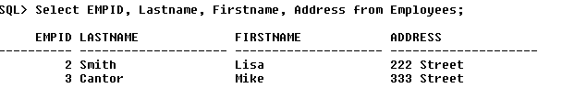

**#6 PRINT SCREEN THE SCRIPT WITH THE RESULTS BELOW HERE**

Notice here that we are not using the (*) instead specifying which columns to retrieve.

Concatenation

Concatenation is when two or more columns are bound together.



OR



Using alias names



Placing symbols in concatenations



**SUBMIT THIS DOCUMENT TO MODULE 1 CLASS EXERCISE #1**